Lab - 4 Time series Forecasting
###clearing the environment and Downloading the required packages
#install.packages("r package", repos = "http://cran.us.r-project.org")
#install.packages('forecast')
#install.packages('tseries')
library('forecast')
## Warning: package 'forecast' was built under R version 4.1.2
## Registered S3 method overwritten by 'quantmod':
## method from
## as.zoo.data.frame zoo
library('tseries')
## Warning: package 'tseries' was built under R version 4.1.2
###Loading and printing the dataset
data <- AirPassengers
data
## Jan Feb Mar Apr May Jun Jul Aug Sep Oct Nov Dec
## 1949 112 118 132 129 121 135 148 148 136 119 104 118
## 1950 115 126 141 135 125 149 170 170 158 133 114 140
## 1951 145 150 178 163 172 178 199 199 184 162 146 166
## 1952 171 180 193 181 183 218 230 242 209 191 172 194
## 1953 196 196 236 235 229 243 264 272 237 211 180 201
## 1954 204 188 235 227 234 264 302 293 259 229 203 229
## 1955 242 233 267 269 270 315 364 347 312 274 237 278
## 1956 284 277 317 313 318 374 413 405 355 306 271 306
## 1957 315 301 356 348 355 422 465 467 404 347 305 336
## 1958 340 318 362 348 363 435 491 505 404 359 310 337
## 1959 360 342 406 396 420 472 548 559 463 407 362 405
## 1960 417 391 419 461 472 535 622 606 508 461 390 432
###Checking for Unfilled data
start(data)
## [1] 1949 1
end(data)
## [1] 1960 12
sum(is.na(data))
## [1] 0
###Displaying the statistical summary of the dataset
summary(data)
## Min. 1st Qu. Median Mean 3rd Qu. Max.
## 104.0 180.0 265.5 280.3 360.5 622.0
###Plotting ‘data’ (No. of Air passengers Vs Year)
plot(data)
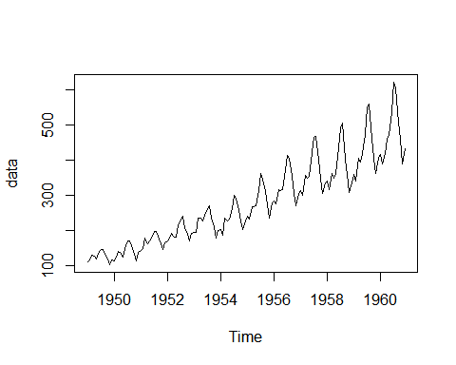 ###Plotting ‘data’ Monthwise
tsdata <- ts(data,frequency = 12)
plot(tsdata)
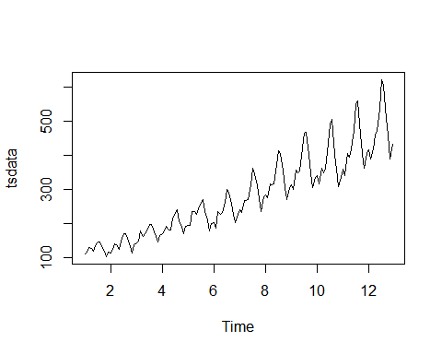 ###Decomposing the data as multiplicative and storing it as ‘ddata’ and plotting the same.
ddata <- decompose(tsdata, "multiplicative")
plot(ddata)
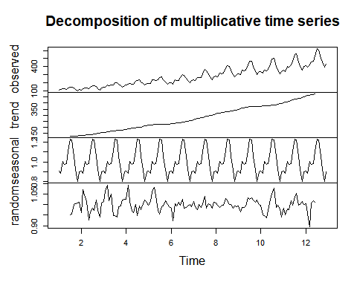 ###Plotting the following: trend, seasonal and random separately.
plot(ddata$trend)
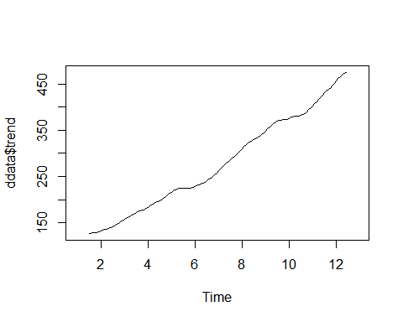
plot(ddata$seasonal)
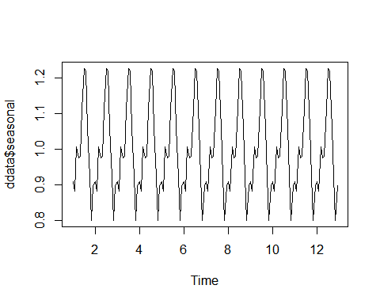
plot(ddata$random)
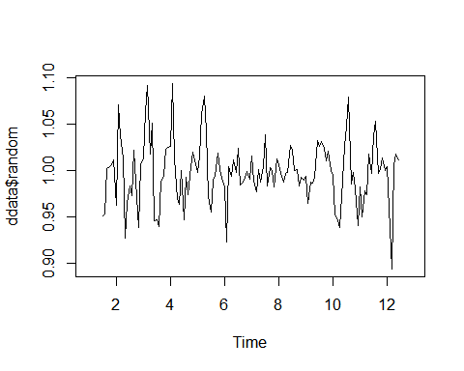
###Performing ADF test for stationarity
adf.test(diff(log(data)), alternative="stationary", k=0)
## Warning in adf.test(diff(log(data)), alternative = "stationary", k = 0): p-value
## smaller than printed p-value
##
## Augmented Dickey-Fuller Test
##
## data: diff(log(data))
## Dickey-Fuller = -9.6003, Lag order = 0, p-value = 0.01
## alternative hypothesis: stationary
###Plotting ACF
acf(diff(log(data)))
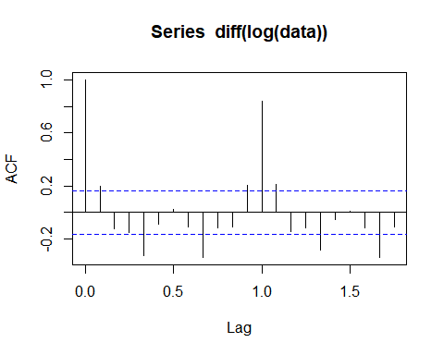 ###Plotting PACF
pacf(diff(log(data)))
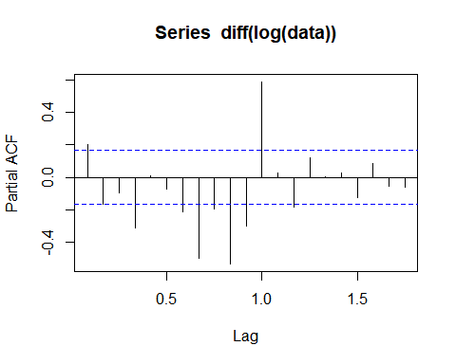
###Model using ARIMA
Adata <- arima(log(data), c(0, 1, 1),seasonal = list(order = c(0, 1, 1), period = 12))
Adata
##
## Call:
## arima(x = log(data), order = c(0, 1, 1), seasonal = list(order = c(0, 1, 1),
## period = 12))
##
## Coefficients:
## ma1 sma1
## -0.4018 -0.5569
## s.e. 0.0896 0.0731
##
## sigma^2 estimated as 0.001348: log likelihood = 244.7, aic = -483.4

